H.T No
Regulations:
A17

Sreenidhi Institute of Science and Technology
(An Autonomous Institution)
Code No: 6B412 Date: 29-Jan-2025 (AN)

B.Tech II-Year II- Semester External Examination, January-2025 (Supplementary)
MACHINE DRAWING AND COMPUTER DRAWING (ME)

Time: 3 Hours Max.Marks:75
Note: a) No additional answer sheets will be provided.
b) All sub-parts of a question must be answered at one place only, otherwise it will not be valued.
c) Missing data can be assumed suitably.

Bloom's Cognitive Levels of Learning (BCLL)

Remember | L1 | Apply | L3 | Evaluate | L5
Understand | L2 | Analyze | L4 | Create | L6

Part - A Max.Marks:2x15=30

Answer any two QUESTIONS.

1. |  | Draw the three views of a square headed bolt of nominal diameter 25 mm and length 100 mm; with a hexagonal nut and washer. | [15M]
2 |  | Sketch the conventional representation of the following:  - External screw threads  - Square on shaft  - Splined shaft  - Spur gear  - Interrupted views | [15M]
3 |  | Draw (i) sectional view from the front and (ii) view from the side of a flanged coupling, indicating proportions, to connect two shafts, each of diameter 40 mm. | [15M]
 |  | Part – B (Compulsory) Max.Marks:45
4. |  | The details of a crosshead of a steam engine are shown in figure. Assemble the parts and draw, (i) half sectional view from the front, showing top half in section and  (ii) the view from the left.  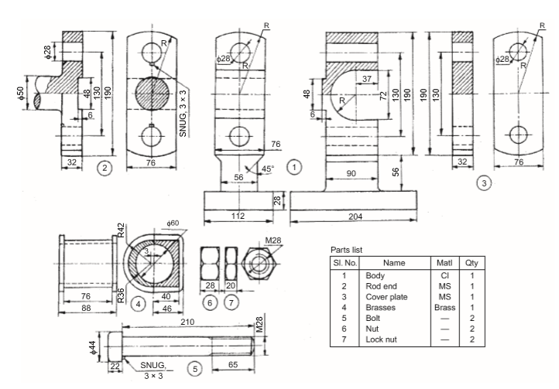 | [45M]

-- 00 -- 00 –

